**Citizens Bank Riverside, San Jose, CA October 2009 to Present**

**Sr. Business Analyst**

**Project: FOREX- Foreign Exchange Trading System Application**

This project was in the Cash Management division. The project Foreign Exchange Trading System Application was the enhancement of the trading system that Citizens Bank used for foreign currency exchange for UK, Canada, and AUS etc.

**Responsibilities:**

* Gathered business and system requirements by conducting detailed interviews with business users, Stakeholders, and Subject Matter Experts (SMEs). Defined the scope of the project, financial projections and Cost/benefit analysis.
* Worked with global stakeholders across time zones to gather specific design requirements and perform analysis and design of various applications
* Hand on experience with liaise with business, develop business requirements documentation, communicate to technical leads and developers, develop test plans and coordinate user acceptance testing.
* Work closely with fixed income and LatentZero program
* Implemented entire Agile/SCRUM methodology of application development with its various workflows, artifacts and activities.
* Involved in planning the requirements development process, determining which requirements are the highest priority for implementation, and managing change.
* Analyzed the objectives, processes and resources
* Analyzed places where Business Process re-design ([BPR](http://en.wikipedia.org/wiki/Business_process_reengineering)), or Business Process improvements ([BPI](http://en.wikipedia.org/wiki/Business_process_improvement)) could be made
* Conducted JAD sessions with management, SME, vendors, users and other stakeholders for open and pending issues. Worked on Agile and Extreme methodologies using TDD, SCRUM.
* Conducted GAP analysis to analyze the shortcomings of the existing system and evaluated the benefits of the new system.
* Responsible for providing business/system requirements within an AGILE software development SCRUM environment.
* Responsible for writing multiple Scrum stories; and ensure that all the documentation is updated with all the requirements.
* Worked on the configuration of SDFC (Salesforce.com) data management tools i.e. CRM fusion according to project/organization requirements
* Worked with stakeholders to develop organizational change plans, training plans, project recommendations, assessments, governance and controls all related to Agile/SCRUM.
* Prepared Business Requirement Document (BRD) and System Requirement Specifications (SRS) then converted Business requirements into Functional Requirements Specification (FRS).
* Identified and developed Use Cases from the business and systems requirements. Documented high level and detailed Use Cases to include all the functionalities of the new system.
* Contributing to software process-reengineering efforts aimed at evolving current software development practices to adopt Lean/Agile and Scrum practices.
* Extensively used Rational Requisite Pro to document and manage requirements. Created and managed project templates, use case templates, requirement types and tractability matrix.
* Followed the Agile/SCRUM methodology to Create UML Diagrams including Use Cases Diagrams, Activity Diagrams, Sequence Diagrams, Collaboration Diagrams, Data Flow Diagrams (DFDs), ER Diagrams using Rational Rose and MS Visio and thus defining the Business Process Model and Data Process Model.
* Worked as primary liaison between business stakeholders and development team for entire project.
* Monitored version control and defect tracking activities using Rational Clear Case and Rational Clear Quest.
* Extensively involved in documenting the test cases and test plans.
* Prepared training manuals for users to educate them about the enhanced system and trained new user on the new system.
* Performed User Acceptance Testing (UAT).

**Environment:**

Rational Rose, Rational Requisite Pro, FOREX, Agile/SCRUM, SDFC CRM Configuration, MS Office (MS Word, MS Excel, MS PowerPoint, MS Visio), Visual Basic, Win Runner, Test Director, Windows 2000, Java, J2EE, Oracle 9i, Oracle My support (Metalinks), Analytics

**Project: FOREX- Foreign Exchange Trading System Application**

This project was in the Cash Management division. The project Foreign Exchange Trading System Application was the enhancement of the trading system that Citizens Bank used for foreign currency exchange for UK, Canada, and AUS!

This project was in the cash management division. It was foreign exchange trading application. We were enhancing the system that Citizens bank (in USA) was using for UK, Canada and Australia. Earlier, they were using Paragon application which was not able to satisfy the client’s (institutional investors a.k.a. wholesale customers as well as regular high net worth individuals a.k.a. retail customers) needs to trade in international markets. However, using Fidessa LatentZero (I worked on implementing it), they could trade in international markets using US accounts. Before, when they were using Paragon application, Citizens banks clients could not buy UK, Canada and Australian stocks directly. They had to go through a stock trader in Citizens bank and route the trades through them. Citizens banks clients were stuck only trading in US stocks by themselves. With Fidessa LatentZero, a Citizen bank client (like John Doe) can trade international securities sitting in USA. LatentZero was exposed to end clients like you and me.

**Tell me about this project?**

[**http://www.citizensbank.com/pdf/personal/CB_ForeignExchange.pdf#page=1**](http://www.citizensbank.com/pdf/personal/CB_ForeignExchange.pdf#page=1)

**I worked on an application called CBForex which was used by Citizens bank’s customers. These customers could be retail customers or could be wholesale customers.**

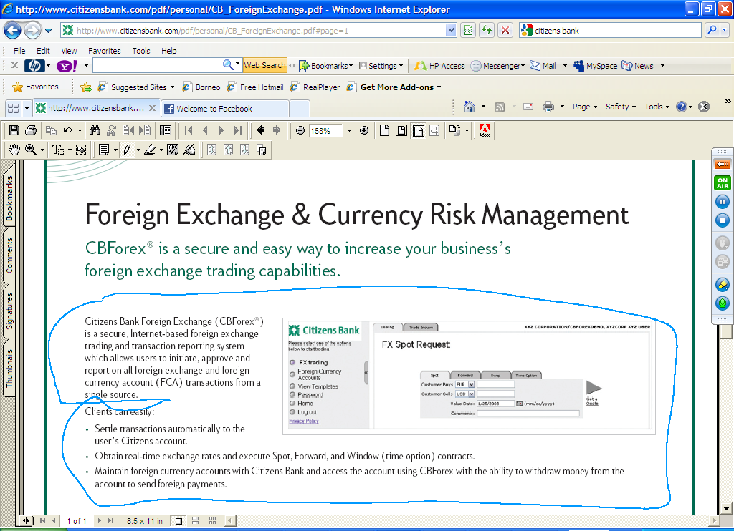

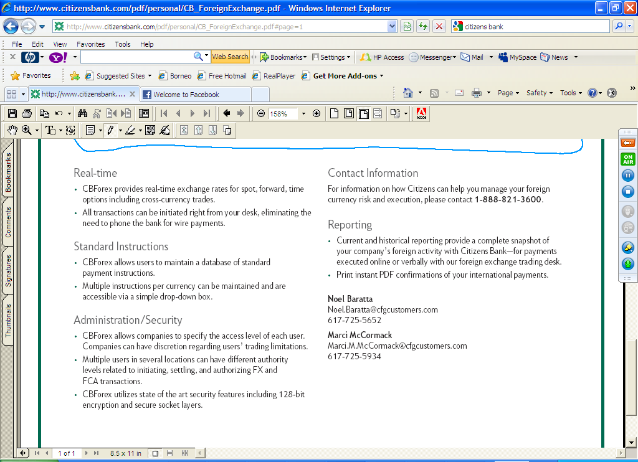

**Where was the Forex information coming from?**

**Bloomberg?**

**How did you make sure about the security of the application?**

**https; the clients that we have (companies) could give different levels of access to its employees. So, the CEO/CFO/COO level people had no trading limitations but say the HR Manager had restricted accounts which needed approval from C level executives beyond a certain amount. I was responsible for setting up this roles and limitations matrix!**